

STAFF BULLETIN
Week Commencing 13 October 2014

HEAD’S FOCUS FOR THE WEEK: To ensure that final preparations for Open Week are in place.

Assemblies: HOY Assemblies – Yrs 7, 8, 9 10 cancelled
VI Form Assembly: Mr R Craig (cancelled on Tuesday)

SLT to meet daily at 8.30am

On Roll: Ella Cholerton Year 9

Collective Act of Worship: Work

All classroom bookings to be made through Cover Manager
All other room bookings to be made through Mrs H Frost

Mon 13/10/2014 Years 7, 8, 9 and 10 assemblies cancelled this week due to Sixth Form exams

8.00am – 6.00pm Mr R Hodges to attend Safer Recruitment - Alec Hunter Village

Year 12 and 13 First Term Exams this week. Timetable later in bulletin

SLT Department Reviews this week

8.00am RA Meeting for Year 9 with Mr P Mower, Mrs T Pepper, Mr D Windeatt, Miss M Gladen, Mrs A Stewart, Miss R Rees, Mr A Beedham and Mr G Flowers in the B&E Board room

Student Council year group meetings this week

9.00am – 2.45pm Twenty Twenty Learning to present ‘Big Idea’ Maths and English sessions to selected Year 7 students in the B&E Conference room. Student names later in bulletin

9.00am – 5.00pm Hair and Beauty trip to the Excel Centre in London accompanied by Mrs L Harper, Mrs J Flowers and Mrs C Warman. Student names later in bulletin

9.30am Mr J Meek to meet with Mrs Harrison and Luke

Pd 2 Mr C Carrott to meet with Miss S Hayward ITT obs

Pd 4 Mr M Harper to meet Mr A DeWet re Performance Management

12.30pm Maggie Loveday, Specialist teacher in school to see three students

1.30pm Mr J Meek to meet with Maggie Loveday

2.45pm – 3.45pm Food and Nutrition session with Mrs S Morgan in DT4

2.45pm – 3.45pm Beauchamps Buddies Club with Mr A Farrugia in BE3

3.00pm NQT/ITT Meeting – Pushing for A* with Miss M Turner in the Admin Meeting Room

3.00pm Mr M Harper to meet Mr R Merry re Performance Management

3.00pm – 5.00pm Years 9, 10 and 11 Netball v Billericay (away)

3.00pm – 5.30pm Year 7 Rugby v Mayflower (away)

3.00pm – 5.30pm Senior Football v De La Salle (away)

3.00pm – 6.00pm Year 9 Football v Basildon Academy (home)

3.15pm Mr N Sydenham and IT Team to meet in Lab 9

6.00pm Governors Curriculum Committee meeting

Tue 14/10/2014 10.00am Mrs H Frost to meet with M Berry of Atkins and T Curnick of NCC Builders re extension build

12.15pm Mr J Meek and Mrs E Long to meet with Scott Gailer, Occupational Therapist

1.45pm Mr J Meek to conduct annual review meeting with Mrs Walsh and Charlie

Pd 5 Year 7 Road Safety Presentation in the West Hall. Teachers of Year 7 classes to register students, then take them to the hall and stay to supervise

2.30pm – 6.00pm Essex Cup Football at Great Notley High School in Braintree, accompanied by Mr C Bryan. Student names later in bulletin

2.45pm – 3.45pm History drop-in clinic with Mrs I Butler and Mrs H Tweedie in C3/C4

2.45pm – 3.45pm Business coursework session with Mr R Merry and Mr A Farrugia in BE3

3.00pm – 4.00pm Year 11 ICT catch-up session with Mr C Carrott in PC4

3.00pm – 5.00pm Year 9 and 10 Netball v De La Salle (away)

4.00pm – 6.00pm Year 8 Rugby Tournament at Basildon Rugby Club

5.00pm – 7.00pm Family Fun with Computers course with Poonam Singh in PC7

Wed 15/10/2014 8.30am Staff briefing – B&E Conference room

Mr K Gladwin (external tutor) to visit Miss A Dunn

9.00am – 2.00pm Mr R Hodges to attend Wickford Heads meeting at Runwell

9.00am Mr J Meek to meet with Miss A Farrar

Year 7 Transition Reports SL deadline

Year 12 and 13 Tracking A1 SL deadline

10.00am Mrs H Frost to meet with Mr C Beauchamp for Responsible Officer review

2.00pm Mr J Meek to meet with Mrs H Bartlett

3.00pm Year Group meetings

2.45pm – 4.00pm Beauty Therapy/Hair Care Course for Year 9 students with Mrs L Harper in the Hair and Beauty Academy

3.00pm – 5.00pm U16 Essex Cup Netball v Grays Convent (home)

Thu 16/10/2014 Mr M Harper and Mr R Merry on course all day

8.30am – 3.30pm Local Democracy Youth Conference at County Hall in Chelmsford accompanied by Mrs S Acton. Student names later in bulletin

9.00am ECM meeting with Mr R Hodges, Mr A Cullers, Mr D Windeatt and Mr J Meek

Pd 2 Year 11 (class 11BBL) BTEC Business on-line test

Pd 5 Year 11 (classes 11BBM1 and 11BBM2) BTEC Business on-line test

2.45pm – 3.45pm Geography revision session with Mrs K Knight in H4

2.45pm – 3.45pm History drop-in clinic with Mrs I Butler and Mrs H Tweedie in C3/C4

2.45pm – 3.45pm Young Apprentice Programme session with Mr R Merry in DT3

2.45pm – 3.45pm Food and Nutrition session with Mrs S Morgan in DT4

2.45pm – 5.30pm ‘A’ Level Maths session with Mr D Carlton and Mr T Moss in M4

3.00pm – 4.00pm BTEC Animal Care Course with Miss A Sampson and Mrs T Vann in Lab 1

3.00 – 5.00pm Teaching Staff Twilight for Performance Management Target Setting. When not in PM meetings, staff to work on DIPSEF and updating class context packs

3.15pm SLT meeting

Fri 17/10/2014 Mr J Meek on a course all day

9.30am to 10.30am Open Day tours for Wickford Junior School Year 6 students and parents. Staff conducting tours: Mr R Hodges, Mr A Liddell, Mrs T Pepper and Mr D Windeatt. Timetable later in bulletin

12.00pm Deadline for entries to be sent to Mrs J Chlopas for the Bulletin – please email Mrs L Pearson any item after this time to be included on the Daily Messages

Pd 4 Year 11 (class 11BBJ) BTEC Business on-line test

12.30pm – 3.00pm Mr A Farrugia to visit Hilltop Junior School to deliver an enterprise session and promote Primary Links

Pd 5 Year 11 (classes 11BBK1 and 11BBK2) BTEC Business on-line test

2.45pm – 3.45pm Maths Club with Mr A Beedham in M2

Registration – Year 7-11 students to complete weekly achievement sheets

Gold 100% attendance stickers to be issued by tutors at Friday registration (any staff who need more please see Main Office)

Form Tutor Monitoring Sheets (Upper School to Mr D Windeatt and Lower School to Mr P Mower) by 3.00pm

HOY Weekly HW diary monitoring sheets due to HOUS/HOLS by 3.00pm

Twenty Twenty Learning ‘Big Idea’ Maths and English Sessions – Monday 13 October

9.00am to 11.30am
Bridget Aarons-Strachan Charlie Walsh Cameron Gulnezer
Yasmine Bellyou Kai Warton Rahim Hassan
Sammie Coltart Cameron Wilkes Daisy Jordan
Maya Cronin Georgie Jackson Evan Lugard
Alex Crossley Harvey Soyer Danny McKenna
Honey Jones Martina Steikunaite Mia Turvey
Ronnie Regan Alfie Carter Lewis Edwards
Kiah Victor

11.30am to 2.45pm
Molly Cronin Tate O’Rourke Honey Jones
Charlotte Emmons Grace Stephenson Ronnie Regan
Sydney Goodacre Bethanie Taylor Kiah Victor
Billy Greenslade Joshua Townsend Charlie Walsh
Amber Knight Alfie Allen Cameron Wilkes
Amie Lane Yasmine Bellyou Walid Zidani
Jessica Morley-Martin Sammie Coltart Oakley Humbles
Chloe Musgreaves Alex Crossley Alfie Leeves

Hair and Beauty Trade Show Trip – Monday 13 October

Hannah Baker Shania Rich Rosie Linihan
Georgia Bennett Chloe Stone Lilymay Lock
Keavy Boyd Chelsea Watkins Tegan Marsh
Kayleigh Coleman Imogen Bailey-Simpson Kasey Martin
Emma Dines Paris Earl Kayleigh Meeks
Katie Hills Emma Austin Rebecca Nix
Emma Howett Chloe Bax Ellesha O’Malley
Mia Meredew Samantha Bickle Daisy Palmer
Grace Quelch Katie Giles Jasmine Thorne
Jayne Rapley Toni Johnstone Charlotte Vine
Chloe Hogarth

Year 12 and 13 First Term Exams Timetables

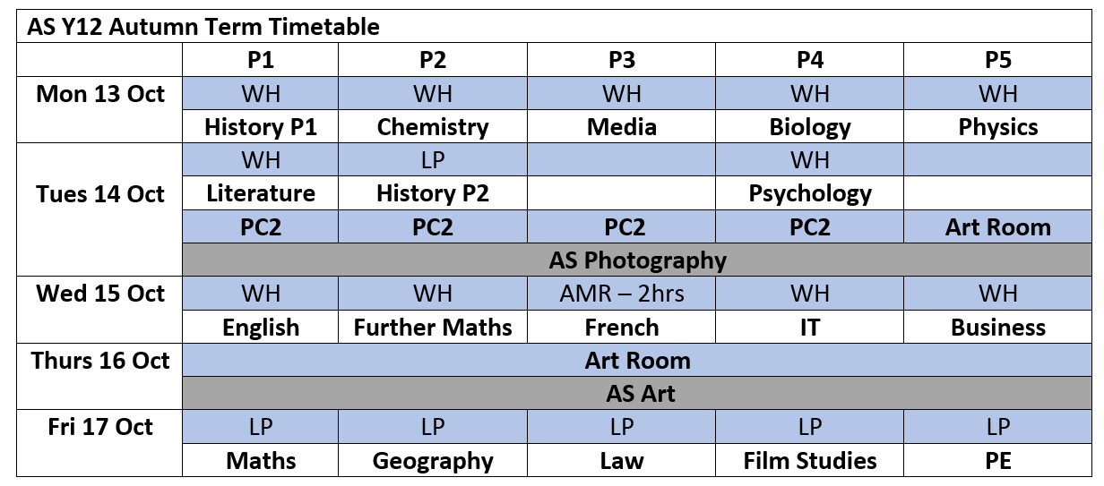
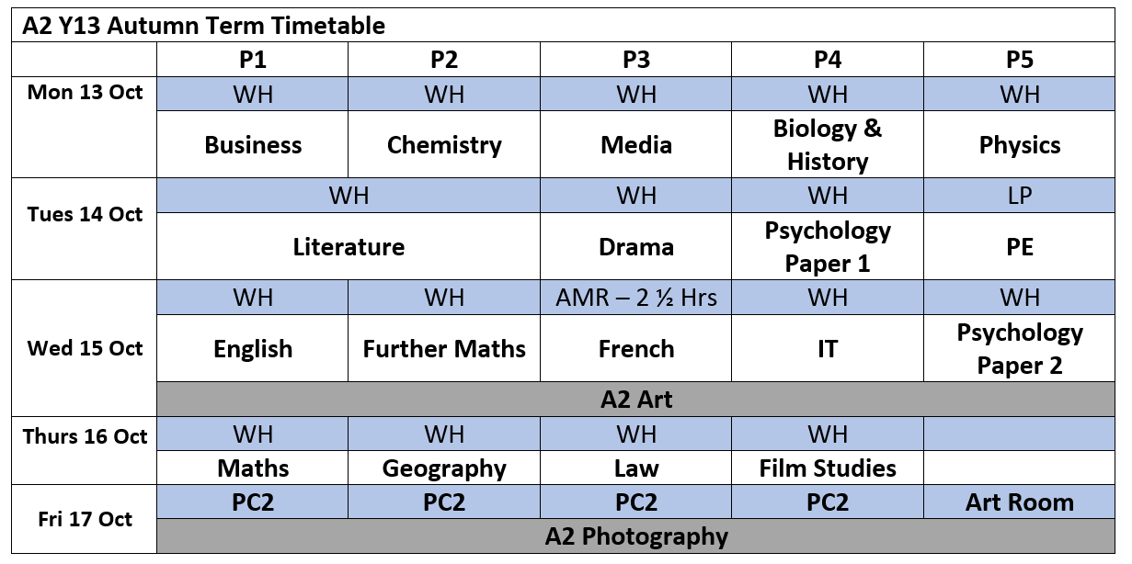

Essex Cup Football – Tuesday 14 October

James Coleman Tommy Robinson Billy Markham
Jamie Smith Olly Cantwell Billy Cox
Hayden Spinks George Pritchard Joe Carter
Owen Croft Tom Kidd Harry Doyle
Josh Read Jake Megran

Local Democracy Youth Conference – Thursday 16 October

Fraser Saunders Charlotte Skeggs Caitlin Ride
Matthew Goddard Isabella Browse Charlotte Taylor
Matthew Edson

Room Bookings | B&E Board Room | B&E Conf Room | West Hall | West Dining Area | Interview Room
Monday
Tuesday | Pd 1 AS Film Studies  2.45pm AS Film Studies
Wednesday
Thursday
Friday

Attendance |  | Punctuality
Week commencing 29 September 2014 |  | Week commencing 29 September 2014
Year 7 | 14A – 100.00% | Year 7 | 14C – 100.00%
Year 8 | 13A - 97.3% |  | 14E – 100.00%
Year 9 | 12A - 99.4%
Year 10 | 11A - 97.7%
Year 11 | 10U - 98.4%

Tutor Group: 14A receive 100.00% Excellent Attendance Certificate

STUDENTS ON REPORT

Year 7 Kane Bartlett HOY report

Year 8 Jon-Alfie Dean, Khaled Al-Aswad HOY report

Year 9 Daniel Gray, Billy Forbes HOY report

Year 10 Mikey Tegg HOY report

Year 11 Jake Liddell, Jordan Fox, Ben Hull, Mitchell Cadd, Michael Evenden
Jaime Joyce break and lunch HOY attendance

Open Day Tours – Friday 17 October
Friday | P1 9:30 |  | Friday | P1 9:30
Hairdressing |  |  | PE | Year 8
 |  |  |  | Various
A5 | 11En3b |  | H4 | 7pGg
 | KRa |  |  | SJa
A4 | 7mEn |  | LAB8 | 9Sc3d
 | TBr |  |  | TKi
B1 | 7c Pd |  | LAB2 | 10Ch1
 | JDo |  |  | SRe
C2 | 10HiL |  | PC1 | 11Ma3c
 | ACo |  |  | PMw
DT4 | 8Te2 |  | PC3 | 10L/Rt1
 | GJs |  |  | JGd
DT5 | 13MdB |  | PC4 | 12ItD
 | KMi |  |  | CCa
BEC | FREE |  | L6 | FREE
Bell goes |  |  | Bell goes
 | P2 |  |  | P2
M1 | 10MuM |  | L5 | 7h Fr
 | RBy |  |  | VCh
BE3 | 10BsM |  | L1 | 12Ps D
 | MHp |  |  | GCr
AR2 | 10Ar M |  | M3 | 8z3 Ma
 | JMe |  |  | MTu
AR1 | 10XT1M |  | DR1 | 7m Dr
 | CBi |  |  | HBo
DR1 | 7m Dr |  | BE3 | 10BsM
 | HBo |  |  | MHp
M3 | 8z3 Ma |  | M1 | 10MuM
 | MTu |  |  | RBy
L5 | 7hFr |  | AR1 | 10XT1M
 | VCh |  |  | CBi
L1 | 12Ps D |  | AR2 | 10Ar M
 | GCr |  |  | JMe
PC2 | 11CH2 |  | DT5 | 10MdM
 | ALi |  |  | KMi
LAB1 | 11Sc1 |  | B2 | 9Re3c
 | ASt |  |  | STe
H2 | 7eGg |  | DT4 | 7p Pd
 | NBa |  |  | GJs

COLLECTIVE ACT OF WORSHIP
Week Beginning
13 October 2014

WORK

“The Lord God took man and put him in the Garden of Eden to till it and care for it”

(Genesis 2, Verse 15)

“Work is a good thing – through work man not only transforms nature, adapting it to his own needs, but he also achieves fulfilment as a human being and, indeed, in a sense becomes more a human being”

(Human Work – Pope John Paul II)

Why is work important to people?

How does work help us control the way we live?

“A vocation means that we see what we do, as an expression of our faith and a response to God’s love for us”

(What does Methodism think?)

Why is it important to use our talents in our work?

How does work make a person feel valued?

What do you need to do to ensure that you can use your talents for work in the future?
Detentions Record week beginning 6 October 2014
Surname | Forename | M/F | Reg | Incident | Action Date | Actioned By
YEAR 7
Bartlett | Kane | M | 7p | Unsafe behaviour | 08 October 2014 | Mr G Jenkin-Smith
Lepper | Joshua | M | 7p | Breach of Exam Conditions | 10 October 2014 | Mr J Doran
Jones | Oliver | M | 7u | Lack of Homework | 06 October 2014 | Miss M Copping
Woodthorpe | James | M | 7u | Lack of Homework | 06 October 2014 | Miss M Copping
YEAR 8
Al-Aswad | Khaled | M | 8a | Behaviour | 08 October 2014 | Miss A Farrar
Choto | Lawrence | M | 8b | Behaviour | 07 October 2014 | Mr J Doran
Bennett | Louis | M | 8c | Failure to attend previous detention | 09 October 2014 | Miss A Farrar
Gill | Liam | M | 8c | Lack of Homework | 07 October 2014 | Miss A French
Watts | Megan | F | 8c | Lack of Homework | 07 October 2014 | Miss A French
Dibattista | Adrian | M | 8h | Rude to staff | 09 October 2014 | Mrs S Morgan
Postles | Benjamin | M | 8h | Failure to attend previous detention | 09 October 2014 | Miss A Farrar
Dean | Jon-Alfie | M | 8m | Lack of Homework | 06 October 2014 | Miss M Copping
Dean | Jon-Alfie | M | 8m | Disruptive Behaviour | 10 October 2014 | Mr D Hickey
Slaven | Angel | F | 8m | Lack of Homework | 06 October 2014 | Miss N Bailey
YEAR 9
Asiji | Chino | F | 9a | Failure to attend previous detention | 09 October 2014 | Mr I Noakes
Dines | Lewis | M | 9a | Lack of Homework | 06 October 2014 | Mr I Noakes
Dines | Lewis | M | 9a | Failure to attend previous detention | 09 October 2014 | Mr I Noakes
Mayles | Jack | M | 9a | Lack of Homework | 09 October 2014 | Mr J Goodacre
Morgan | Gavin | M | 9a | Assault - Pupil | 06 October 2014 | Mr N Sydenham
Poulter | Luke | M | 9a | Lack of Homework | 09 October 2014 | Mr J Goodacre
Charlick | Saskia | F | 9b | Lack of Homework | 09 October 2014 | Mr J Goodacre
Glaze | Emily | F | 9b | Lack of Homework | 09 October 2014 | Miss A Farrar
Edwards-Busher | Samantha | F | 9c | Rude to staff | 09 October 2014 | Miss L Evans
Lamy-Cauchi | Craig | M | 9c | Disruptive Behaviour | 08 October 2014 | Mr J Goodacre
Milbourn | Bradley | M | 9c | Lack of Homework | 09 October 2014 | Mr J Goodacre
Mulenga | Mukuma | M | 9c | Lack of Homework | 06 October 2014 | Miss M Copping
Mulenga | Mukuma | M | 9c | Lack of Homework | 09 October 2014 | Mr J Goodacre
Mackie | Luke | M | 9e | Lack of Homework | 09 October 2014 | Mr J Goodacre
Wright | Marina | F | 9e | Persistent Lateness to School | 09 October 2014 | Mr P Mower
Anderson | Jimmy | M | 9h | Lack of Homework | 09 October 2014 | Miss A Farrar
Cole | Finley | M | 9h | Behaviour | 10 October 2014 | Mr J Doran
Dixon | Caitlin | F | 9h | Persistent Lateness to School | 09 October 2014 | Mr P Mower
Hales | Johnny | M | 9h | Lack of Homework | 09 October 2014 | Miss A Farrar
Hales | Johnny | M | 9h | Failure to attend previous detention | 09 October 2014 | Mr I Noakes
Haselden | Kayley | F | 9h | Lack of Homework | 09 October 2014 | Miss A Farrar
Abdulrahman | Khalid | M | 9m | Disruptive Behaviour | 06 October 2014 | Mr L Mason
Abdulrahman | Khalid | M | 9m | Lack of Homework | 07 October 2014 | Miss A French
Adams | Deyarni | M | 9m | Lack of Homework | 09 October 2014 | Miss A Farrar
Ashdown | Callum | M | 9m | Lack of Homework | 09 October 2014 | Miss A Farrar
Feltham | Joshua | M | 9m | Failure to attend previous detention | 09 October 2014 | Mr I Noakes
Feltham | Joshua | M | 9m | Lack of Homework | 09 October 2014 | Miss A Farrar
Forbes | Billy | M | 9m | Failure to attend previous detention | 09 October 2014 | Mr I Noakes
Forbes | Billy | M | 9m | Behaviour | 10 October 2014 | Mr J Doran
Kent | Maisie | F | 9m | Persistent Lateness to School | 09 October 2014 | Mr P Mower
Madare | Tyren | M | 9m | Lack of Homework | 09 October 2014 | Mr J Goodacre
Madare | Tyren | M | 9m | Failure to attend previous detention | 09 October 2014 | Mr I Noakes
McIlroy | Ryan | M | 9m | Lack of Homework | 09 October 2014 | Mr J Goodacre
Ndoro | Blessing | M | 9m | Assault - Pupil | 06 October 2014 | Mr N Sydenham
Connolly | Alisha | F | 9p | Persistent Lateness to School | 09 October 2014 | Mr P Mower
Despy | Alfie | M | 9p | Rude to staff | 09 October 2014 | Miss L Evans
Gray | Daniel | M | 9p | Lack of Homework | 09 October 2014 | Miss Alison Farrar
Gray | Daniel | M | 9p | Rude to staff | 09 October 2014 | Miss Lara Evans
Gwegweni | Matipaishe | M | 9p | Lack of Homework | 08 October 2014 | Mrs A Conway
Gwegweni | Matipaishe | M | 9p | Rude to staff | 09 October 2014 | Miss L Evans
Edwards | Callum | M | 9u | Lack of Homework | 09 October 2014 | Miss A Farrar
Robinson | Yohance | M | 9u | Lack of Homework | 06 October 2014 | Mr J Doran
YEAR 10
Bassilios | Mark | M | 10a | Lack of Homework | 10 October 2014 | Miss L Evans
Giles | Jonathan | M | 10a | Persistent Lateness to School | 10 October 2014 | Mr M Leslie
Morson | Jack | M | 10a | Lack of Homework | 10 October 2014 | Miss L Evans
Ward | Elle | F | 10a | Persistent Lateness to School | 10 October 2014 | Mr M Leslie
Coleman | James | M | 10b | Lack of Homework | 10 October 2014 | Miss L Evans
Harrison | Joel | M | 10b | Lack of Homework | 07 October 2014 | Mrs A Conway
Alder | Billy | M | 10c | Refusing to follow instructions | 07 October 2014 | Mr D Burkett
Chance | Sid | M | 10c | Lack of Homework | 07 October 2014 | Mrs A Conway
Dawson | Mitchell | M | 10c | Lack of Homework | 10 October 2014 | Miss L Evans
Harding | Ciara | F | 10c | Lack of Classwork | 09 October 2014 | Miss L Evans
Harding | Ciara | F | 10c | Lack of Homework | 10 October 2014 | Miss L Evans
Johnson | Oliver | M | 10c | Lack of Homework | 10 October 2014 | Miss L Evans
McCluskey | Jimmy | M | 10c | Lack of Homework | 10 October 2014 | Miss L Evans
O'Keefe | Callum | M | 10c | Persistent Lateness to School | 10 October 2014 | Mr M Leslie
Frost | Brooke | F | 10e | Lack of Homework | 10 October 2014 | Miss L Evans
Kent | Ellis | M | 10e | Disruptive Behaviour | 07 October 2014 | Miss H Taylor
Kent | Ellis | M | 10e | Failure to attend previous detention | 10 October 2014 | Miss H Taylor
Toye | Bailey | M | 10e | Disruptive Behaviour | 07 October 2014 | Miss H Taylor
Toye | Bailey | M | 10e | Failure to attend previous detention | 10 October 2014 | Miss H Taylor
Hoare | James | M | 10h | Lack of Homework | 10 October 2014 | Miss L Evans
Kyte | Chloe | F | 10h | Persistent Lateness to School | 10 October 2014 | Mr M Leslie
Mann | Symren | F | 10h | Lack of Homework | 10 October 2014 | Miss L Evans
Rich | Shania | F | 10h | Persistent Lateness to School | 10 October 2014 | Mr M Leslie
Gilbert | Ellis | M | 10p | Lack of Homework | 07 October 2014 | Mrs A Conway
Shurety | Mitchell | M | 10p | Lack of Homework | 10 October 2014 | Miss L Evans
Telford | Jordan | M | 10p | Refusing to follow instructions | 07 October 2014 | Mr D Burkett
Greenslade | Danielle | F | 10u | Lack of Homework | 07 October 2014 | Mrs A Conway
Greenslade | Danielle | F | 10u | Lack of Homework | 08 October 2014 | Miss A French
Hall | Oliver | M | 10u | Lack of Homework | 07 October 2014 | Mrs A Conway
YEAR 11
Brockett | Brandon | M | 11b | Lack of Homework | 08 October 2014 | Mrs K Knight
Forstner | Liam | M | 11b | Lack of Homework | 10 October 2014 | Mrs I Butler
Joyce | Jaime | M | 11b | Behaviour | 09 October 2014 | Mr A De Wet
Gardiner | Reece | M | 11c | Lack of Homework | 06 October 2014 | Mrs I Butler
Gardiner | Reece | M | 11c | Lack of Homework | 09 October 2014 | Mrs I Butler
Gardiner | Reece | M | 11c | Persistent Lateness to School | 10 October 2014 | Mrs E Smith
Hull | Benjamin | M | 11c | Behaviour | 06 October 2014 | Mr A Farrugia
Hull | Benjamin | M | 11c | Behaviour | 09 October 2014 | Mr A De Wet
Merritt | George | M | 11c | Planner not signed | 09 October 2014 | Miss K Rayner
Newman | Jake | M | 11c | Planner not signed | 09 October 2014 | Miss K Rayner
Pritchard | Charley | M | 11c | Planner not signed | 09 October 2014 | Miss K Rayner
Anthony | Callum | M | 11e | Lack of Homework | 08 October 2014 | Mrs M Coughlan
Armstrong | Calvin | M | 11e | Lack of Homework | 08 October 2014 | Mrs M Coughlan
Burns | Daisy | F | 11e | Lack of Homework | 09 October 2014 | Mrs I Butler
Evenden | Michael | M | 11e | Lack of Homework | 06 October 2014 | Miss N Bailey
Evenden | Michael | M | 11e | Behaviour | 09 October 2014 | Mr A De Wet
Jones | Billy | M | 11h | Coursework | 06 October 2014 | Mrs S Morgan
Croft | Owen | M | 11m | Lack of Homework | 10 October 2014 | Mrs I Butler
Smith | Jamie | M | 11m | Lack of Homework | 10 October 2014 | Mrs I Butler
Bayraktar | Ishak | M | 11p | Lack of Homework | 08 October 2014 | Mrs M Coughlan
Kidd | Tom | M | 11p | Lack of Homework | 09 October 2014 | Mrs K Knight
Linihan | Rosie | F | 11p | Persistent Lateness to School | 10 October 2014 | Mrs E Smith
Neale | George | M | 11p | Coursework | 06 October 2014 | Mrs S Morgan
Neale | George | M | 11p | Persistent Lateness to School | 10 October 2014 | Mrs E Smith
Fox | Jordan | M | 11u | Persistent Lateness to School | 10 October 2014 | Mrs E Smith
Lennon | Ben | M | 11u | Lack of Homework | 08 October 2014 | Mrs M Coughlan
Nix | Rebecca | F | 11u | Lack of Homework | 08 October 2014 | Mrs M Coughlan
Nolan | Tyler | M | 11u | Persistent Lateness to School | 10 October 2014 | Mrs E Smith
Wright | Jayne | F | 11u | Lack of Homework | 09 October 2014 | Mrs I Butler

